 **LODI ROTARY CLUB** 

# SUSIE DAY PARADE ANNOUNCEMENT

**Saturday, August 10, 2024 at 10:00AM**

Line-Up: Bellin Street beginning at 9:00AM

Please note, Columbus St and Spring St are not available for line up

**This year’s theme: “Susie for President”**

This year the Spring Street Market, will be open from 9am-3pm

The market will include a live band, beer garden, and a variety of vendors

The Duck Derby will be held from 1pm-2pm

Civic organizations, youth groups, equestrian and commercial units are welcome. We thank you for your support of the parade. Please see the following entry fee schedule:

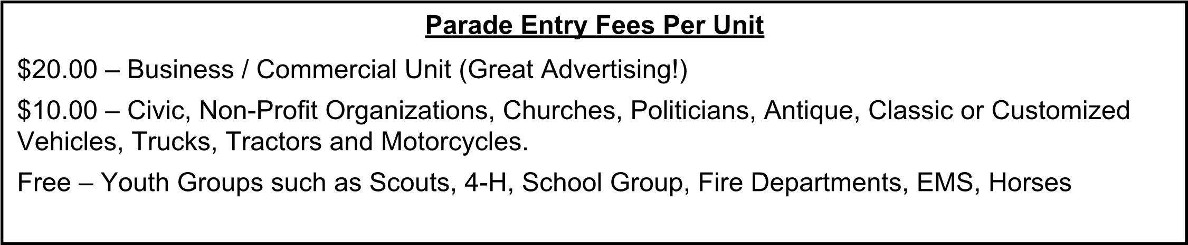

**Rules for Everyone’s Safety**

1. DO NOT throw candy or other items from your parade unit. Have walkers hand out the items near sidewalks.
2. Maintain 2 car lengths between parade units.
3. Keep your unit moving! Do not stop to campaign or perform. You can do that later.
4. Please provide a sign or banner with the name of your group on the passenger side of the float or if a walking group, have someone carry the sign or banner.
5. Return the entry form with fee to Lodi Rotary, Steve Hoerig, address on entry form.

**Entry Deadline August 4, 2024**

## 2024 SUSIE DAY PARADE ENTRY FORM

***SUBMISSION DEADLINE: AUGUST 4, 2024***

**Yes, we would like to enter this year’s parade! We are:**

**ORGANIZATION** : _________________________________________________________________

**ADDRESS:**  ______________________________________________________________________

**CONTACT INFORMATION:**

**Name:**  _____________________________  **Phone:**  ______________  **E-Mail** : _________________  **Name:**  _____________________________  **Phone:**  ______________  **E-Mail** : _________________

|  |  |
| --- | --- |
| **TYPE OF ENTRY (please mark with an “X”):** |  |
| MARCHING / WALKING UNIT ☐  AUTO OR MOTORCYCLE ☐  VEHICLE PULLING TRAILER ☐ | TRACTOR ☐ FLATBED TRUCK ☐  HORSES ☐ |

### Remember the Deadline is: SUNDAY, AUGUST 4 th Please make check payable to: “Lodi Rotary”

**Mail to Lodi Rotary:**

**Steve Hoerig, 314 View St, Lodi, WI 53555**

**Questions? Please call 608-212-5117**

**If I am unable to answer feel free to leave a voicemail**